**NGINX Webserver on Ubuntu**

Step 1- Open a instance connect it. Then install nginx on your ubuntu –

Cmd – apt update -y

apt install nginx

check nginx insalled or not – systemctl status nginx

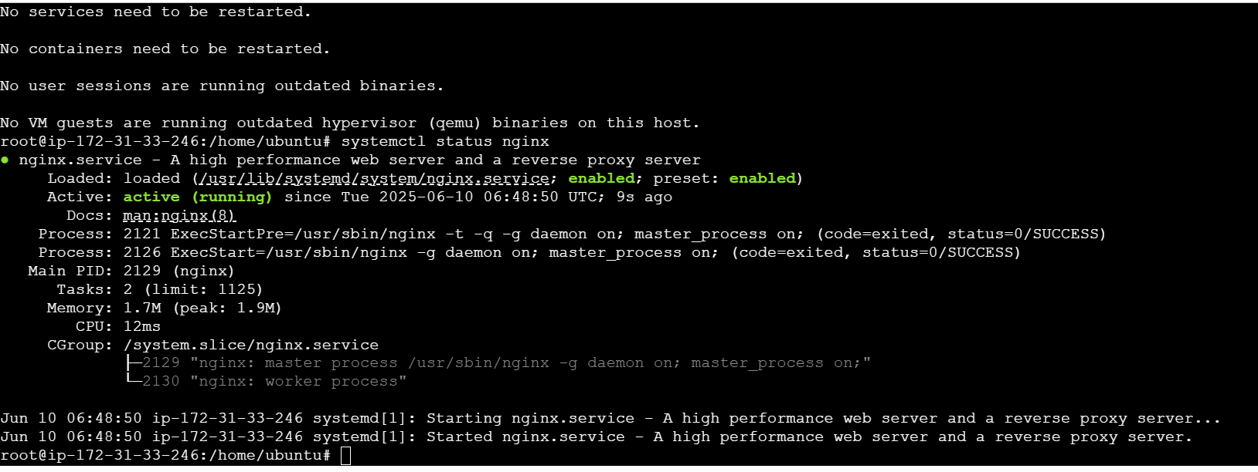

Step2 – The we paste our public IP to browser but it not get connected because of security group. For nginx we need http protocol.

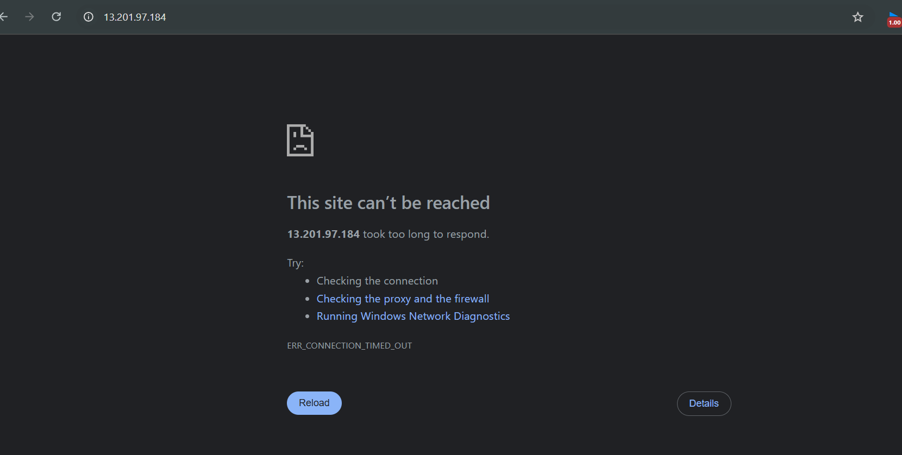

Step 3 – Then open security group and add inbound rules. Enable SSH & Http protocol.

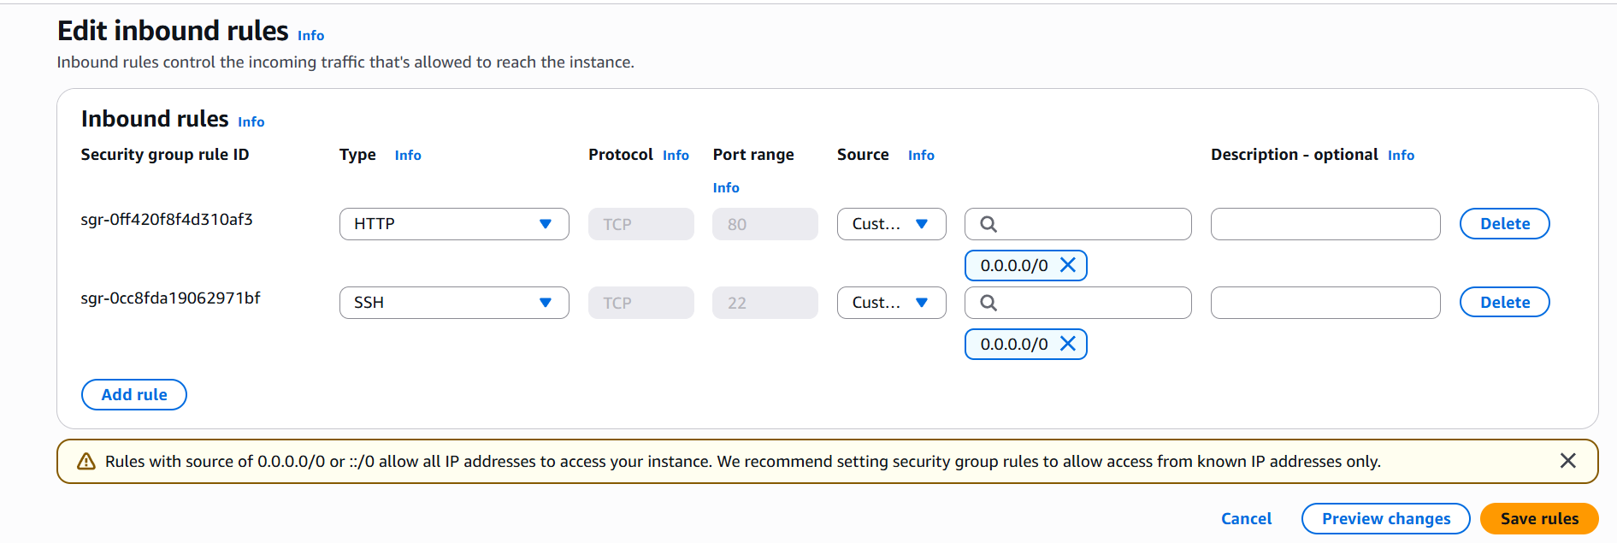

Step 4 - Again reload the page, now we can see our default nginx page.

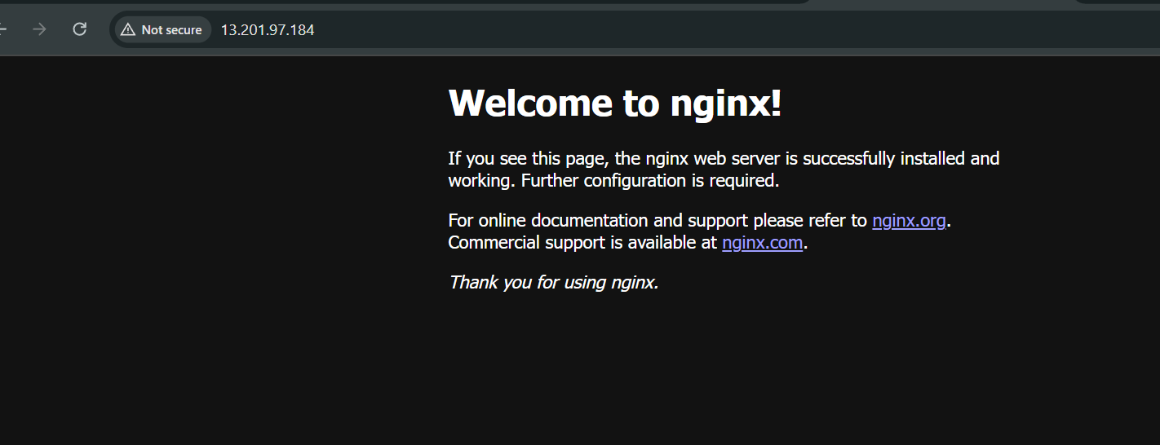

Step 5- Now we do some change in our html code on nginx page, and do some changes.

Connect to Mobaxtem, Go to Session – SSH- paste Remote Host (Public IP)- Specify username (ubuntu)- use private key - ok

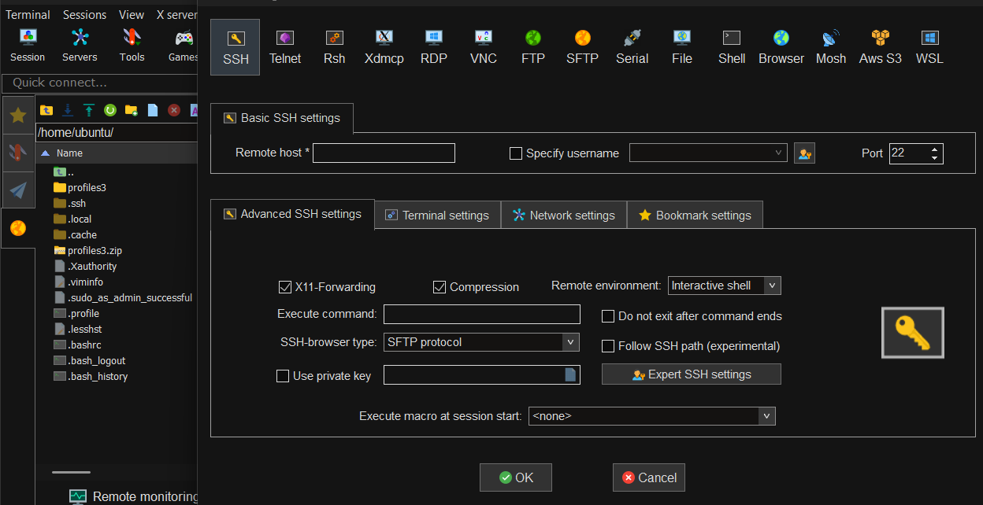

upload a file- go to file location

ls /var/ww/html

ls /var/www/html/index.nginx-debian.html

nano /var/www/html/index.nginx-debian.html

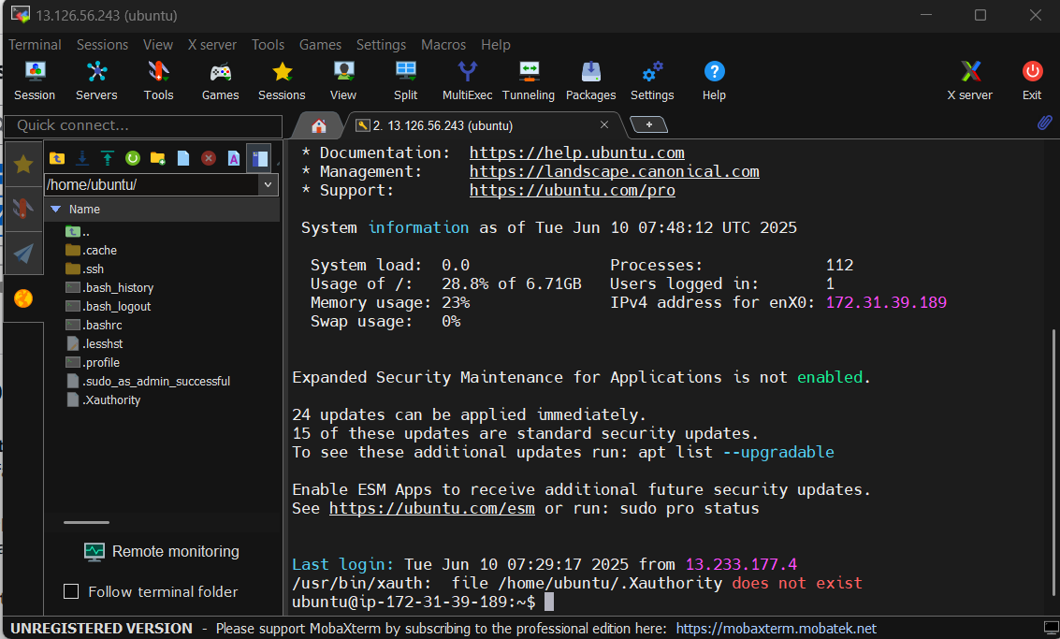

Step 6 – This is our new page as same way we do more changes.

